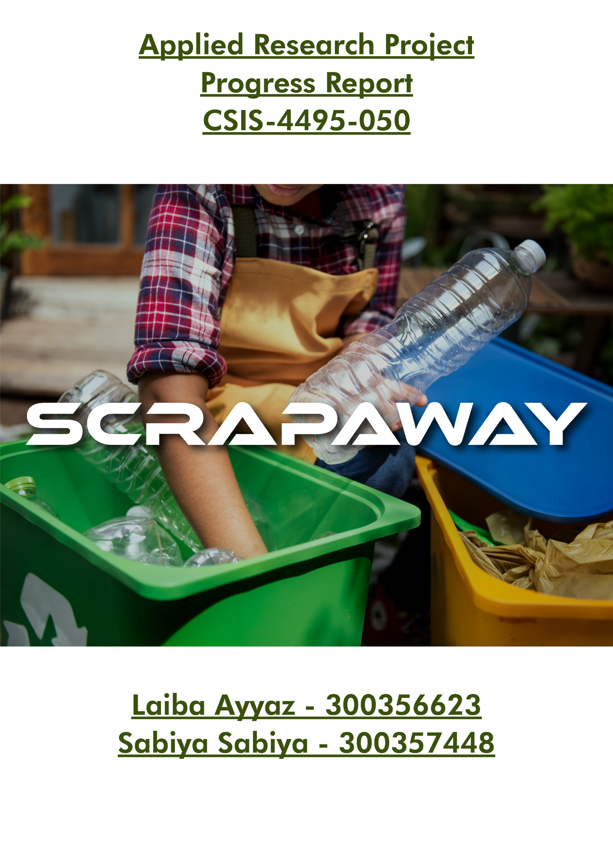

**Progress Report for Applied Research Project**

My partner Sabiya and I have been working on our Waste Disposal project, "ScrapAway," for the past week. We've made good progress, particularly focusing on creating the User Interface for our Homepage.

To kick off our week, we started by designing the logo and branding for our website to maintain a consistent theme throughout. Since we're building a single-page website using React, we took some time to refresh our understanding of React and Node basics. Once we felt confident, we decided to incorporate two navigation bars into our design, breaking down our content into manageable components.

**Implementation**

* **Navbars:** Our website features two navigation bars. The first one provides access to three main pages: the Homepage (accessible by clicking on the ScrapAway logo), a waste sorting guide, and information about our business collaborations. Currently, we've completed the homepage and the waste sorting guide pages.



* **Hero Banner:** The hero banner is the primary banner on our website designed to immediately capture users' attention. We've implemented a carousel feature with automatic image switching to showcase three images.

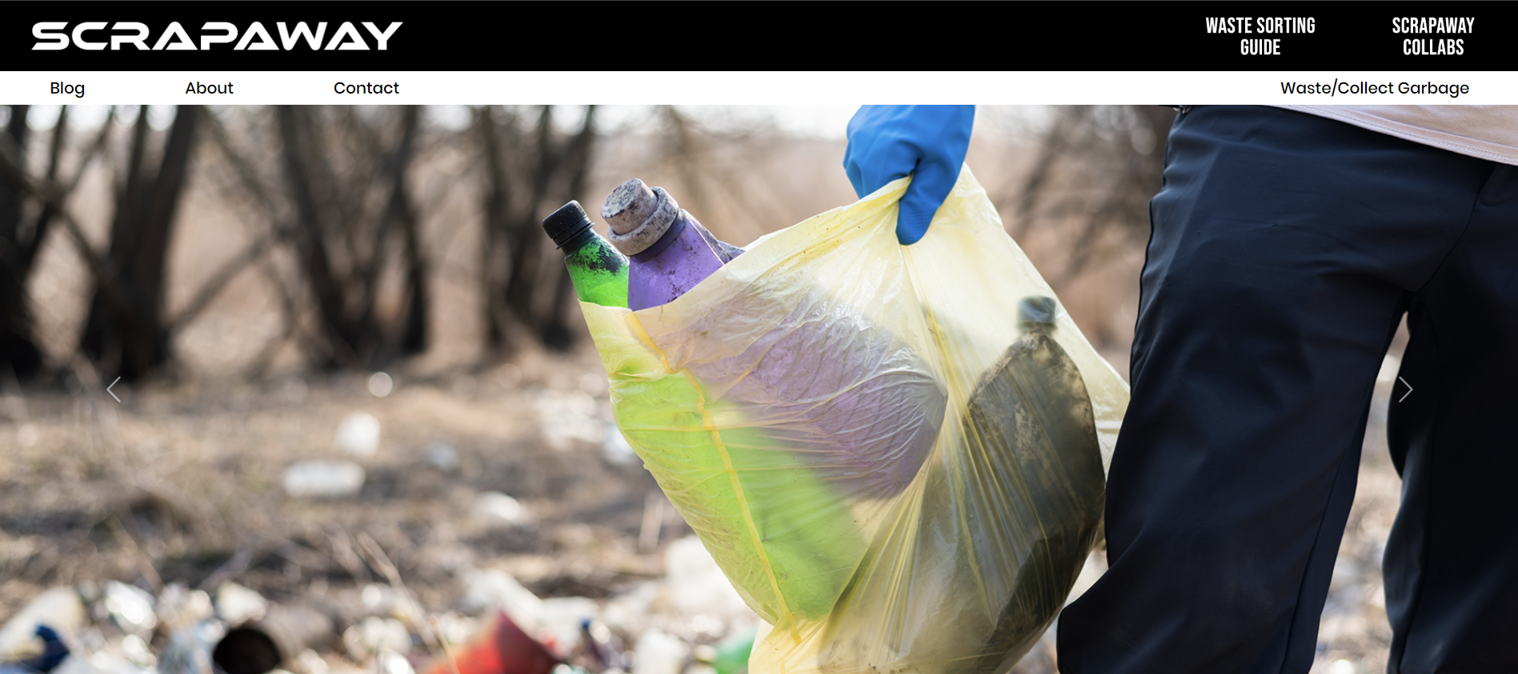

* **Category Type:** This component displays different types of waste along with their corresponding prices. We've created a single component that dynamically fetches data, including images, category names, and prices, from an API built using Node. Like the hero banner, it utilizes a carousel format for easy browsing.

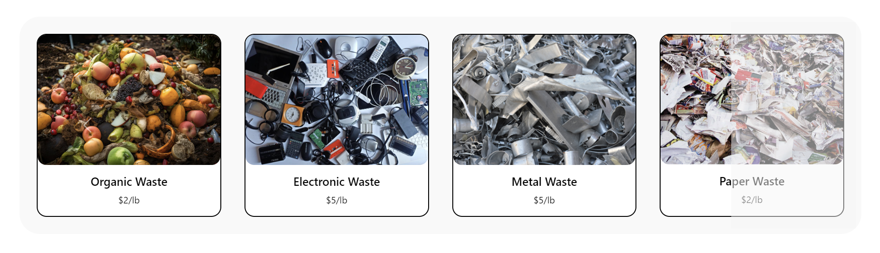

* **How It Works:** Here, we've created an infographic to explain the basic functionality of our website to users.

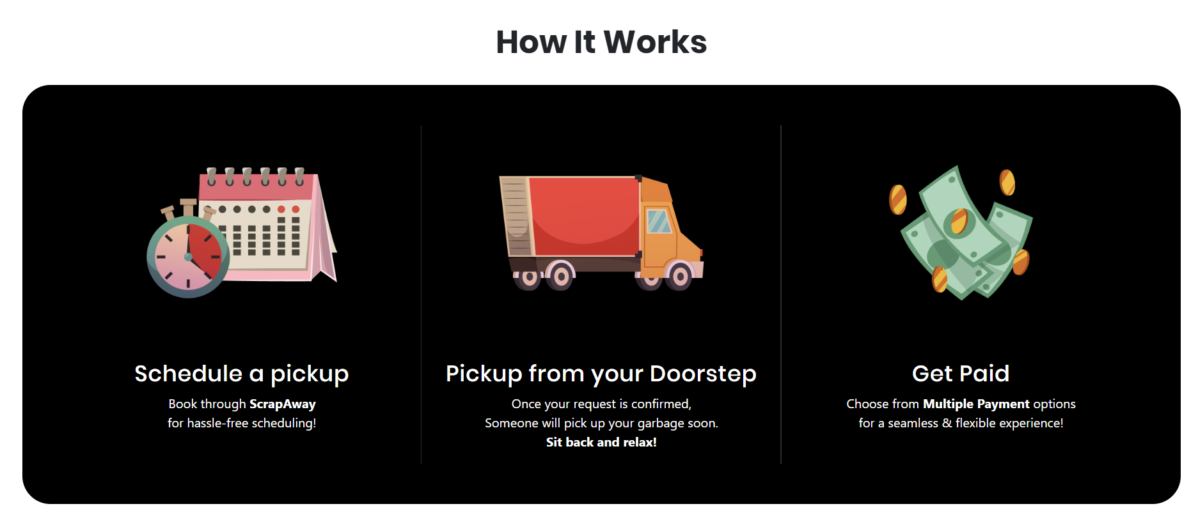

* **Footer:** At the bottom of our homepage, we've included a footer section with copyright information to establish the authority of our website.

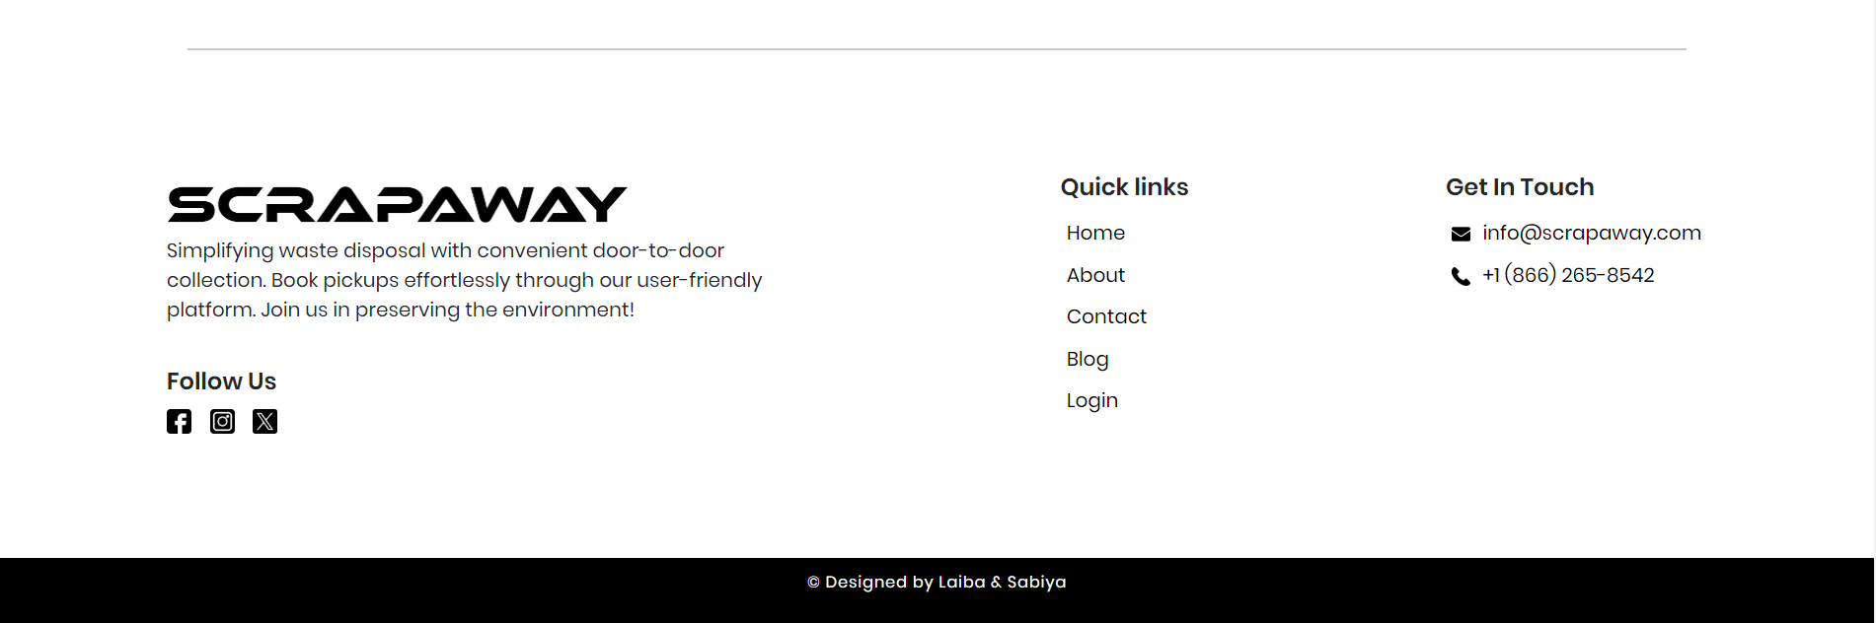

* **Waste Sorting Guide:** This component provides valuable information on how to sort different types of garbage to increase awareness among users.

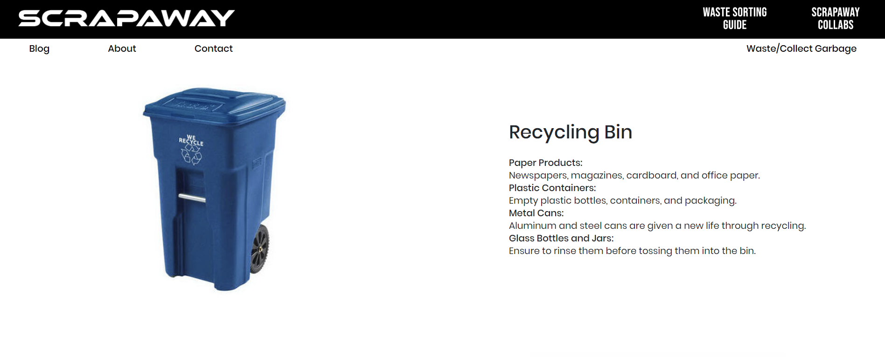

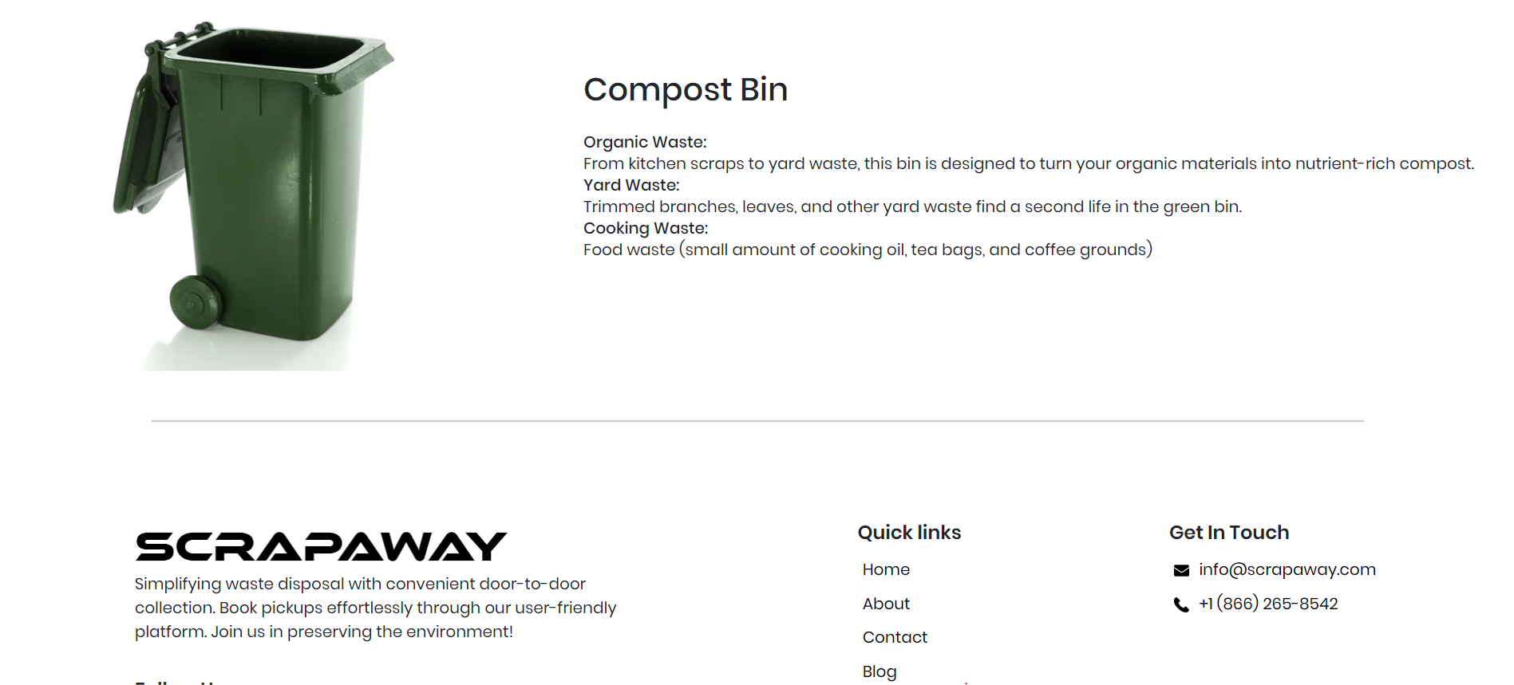

**How to run the project**

1. Open both the ScrapAway-Frontend and ScrapAway-Backend in separate Visual Studio windows.
2. In the terminal, navigate to each project folder and run the command "npm i" to install all necessary dependencies.
3. In the backend folder, run the command "node Server" to start the backend server on port 3005.
4. In the frontend folder, run the command "npm start" to launch our website on localhost:3000.

**Challenges Faced During Integration of API**

In the early stages of our project, we started the development process by using static data for various types of waste along with their corresponding rates. This allowed us to create a foundational structure for the home page and test the user interface with predefined information.

As the project progressed, we decided to transition from static data to a more dynamic and scalable approach by fetching information from an API. This decision presented itself as a significant challenge for our team.

By leveraging online resources and tutorials, we successfully navigated through the complexities of API integration, gaining valuable insights and expertise along the way.

**Conclusion**

Our progress report for "ScrapAway" highlights achievements and future. We designed the platform's look, chose React for smooth functionality, and organized content inspired by [MOSCHINO](https://www.moschino.com/ca_en/moschino.html). Features include a dynamic banner, waste types with prices from our API, a user-friendly guide, and more. We aim to continually improve based on user feedback, striving to simplify waste disposal and support the environment. Overall, we've worked hard, learned a lot, and are eager to enhance ScrapAway further.